**Team 13: Java Swing app, Android and iOS app for IHO department**

Sponsor: Dr. Timothy Lindquist

Jaiswal, Arpit; Bhatt, Mihir; Nayak, Gowtham; Singhal, Sweta; Senathamil, Sindhu

**First Demo or Prototype | Screenshots**

**Update on Java Swing App:** We have successfully created the UI and will continue to enhance the aesthetics in future sprints. We are able to generate JSON form Java Swing app and push it to the server.

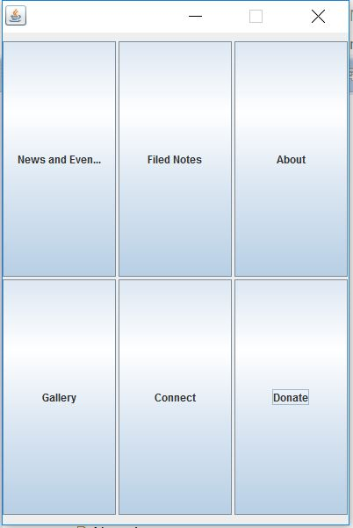

Figure 1: Main Page of the Java Swing Application

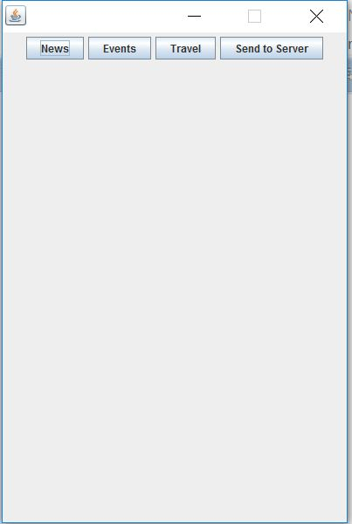

Figure 2: News, Events and Travel Menu Page

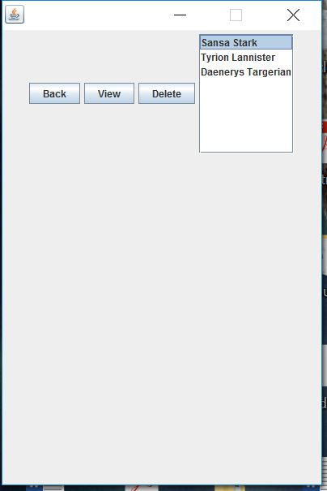

Figure 3: News List with View, Delete button

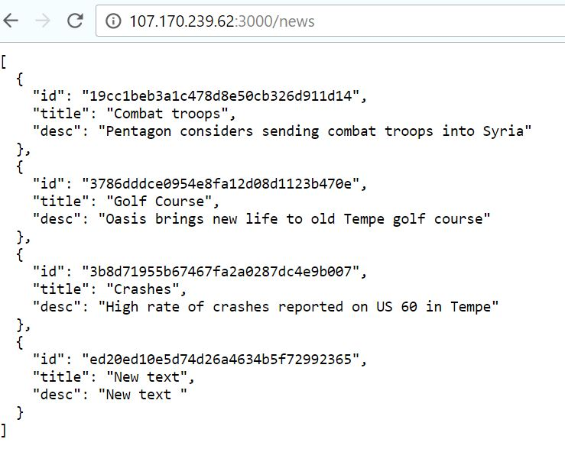

Figure 4: Server before updating the news content

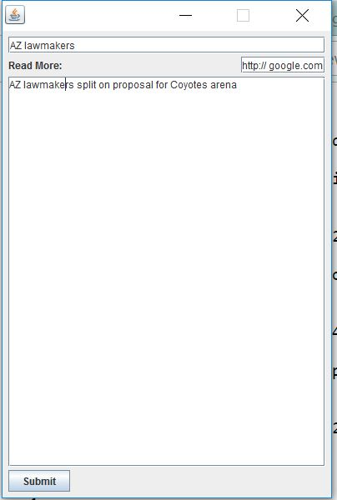

Figure 5: Adding news content

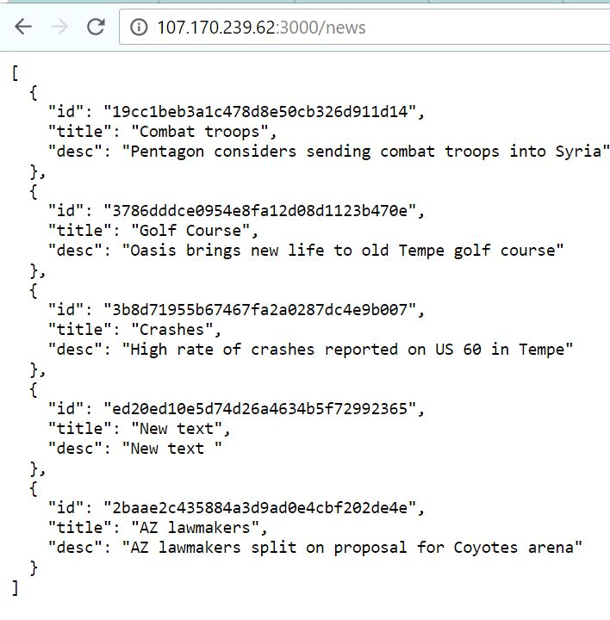

Figure 6: Server after updating the news content

**Update on iOS app:** We are creating the app from scratch in SWIFT 3. In sprint 3 we have completed the iOS app. We have implemented Lucy completed. We have also successfully implemented Gallery and Lecturer Gallery in this phase.

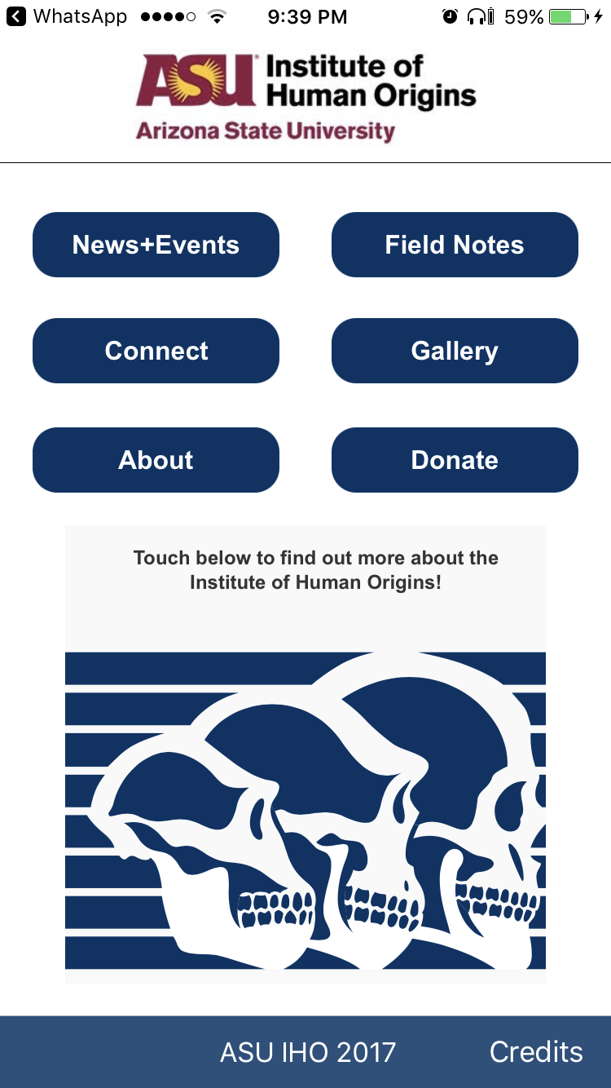

*Figure 7: Home Page of IHO app in iOS*

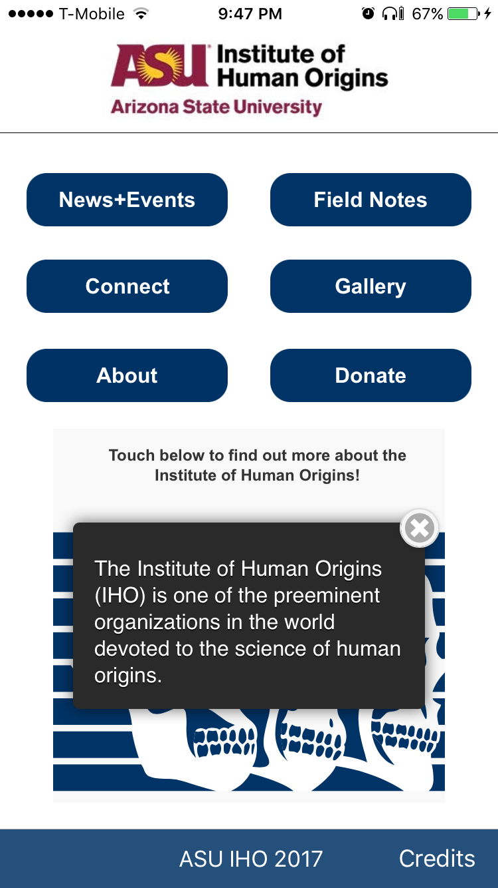

*Figure 8: Interactive Image on Home page which gives pop up when touched various parts..*

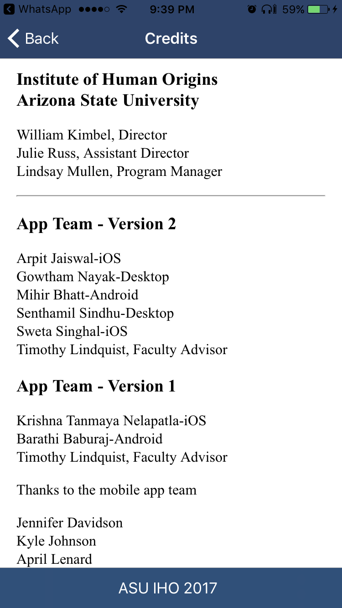

*Figure 9: Credits Pagefor IHO app*



*Figure 10: Gallery Home Page, redesigned with image for gallery home page..*

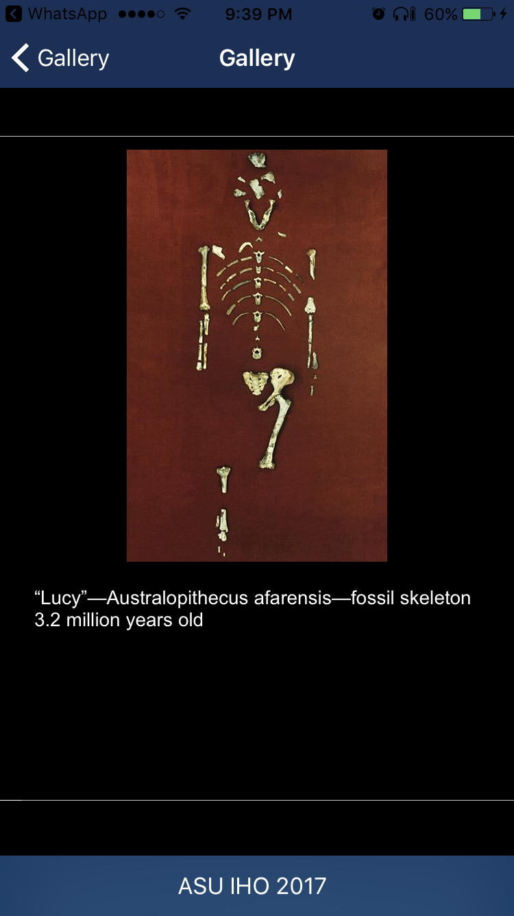

*Figure 11: Gallery with multiple images.*

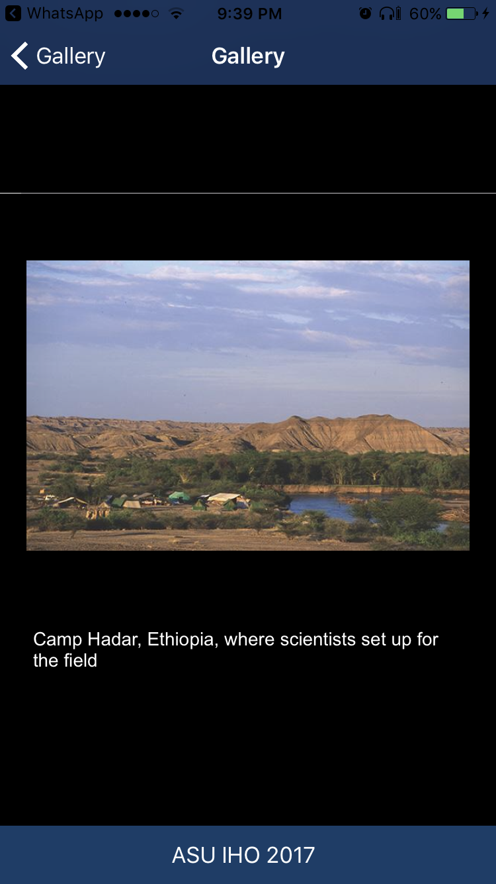

*Figure 12: Image Gallery*

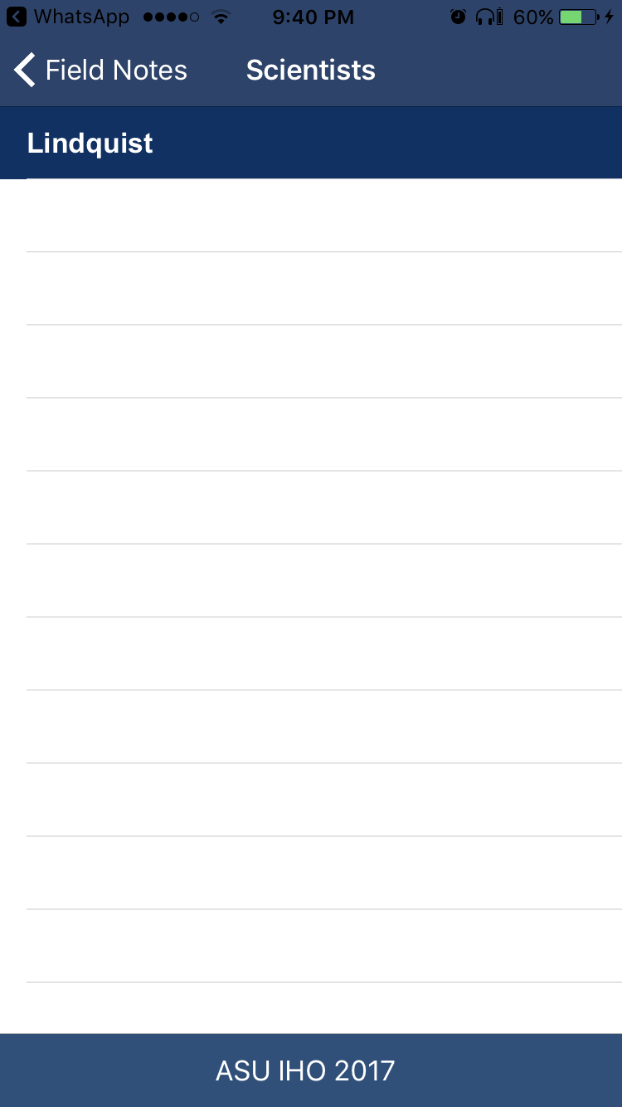

*Figure 13: List of Lecturer with dummy data*

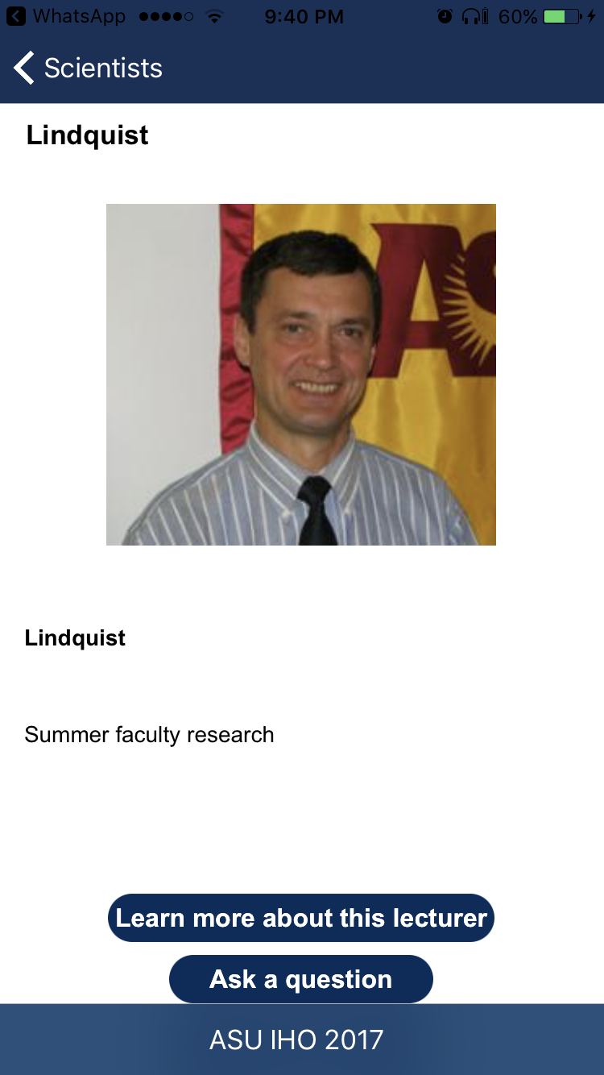

*Figure 14: Lecturer Detail*

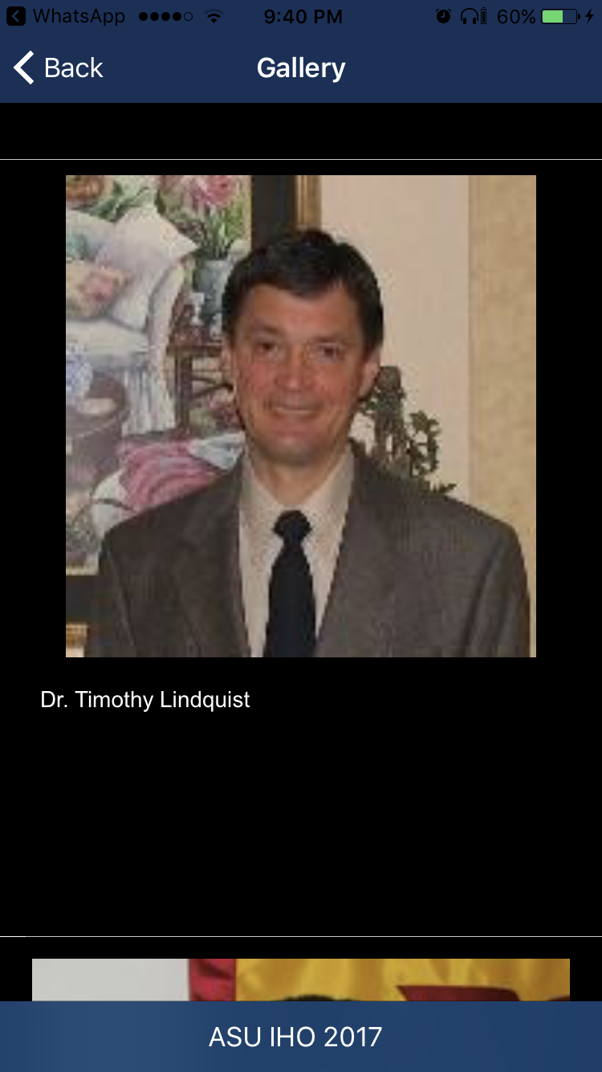

*Figure 15: Lecturer Gallery*

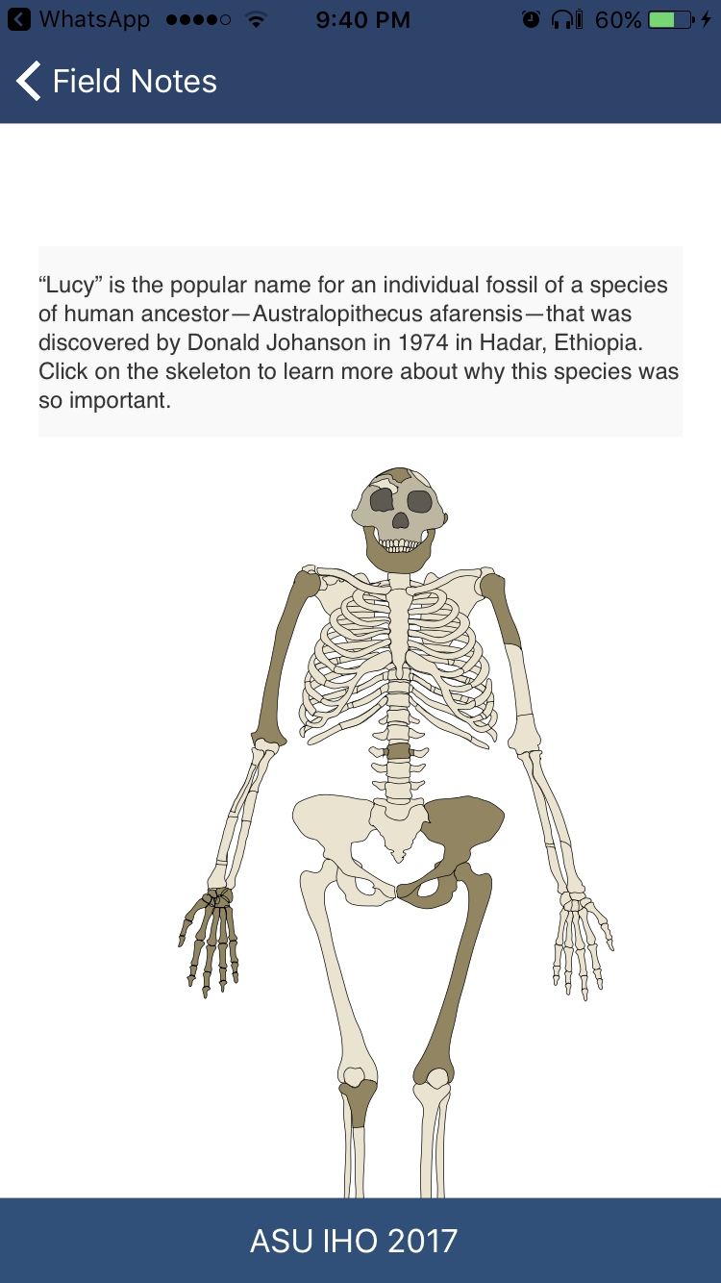

*Figure 16: Lucy Iteractive image*

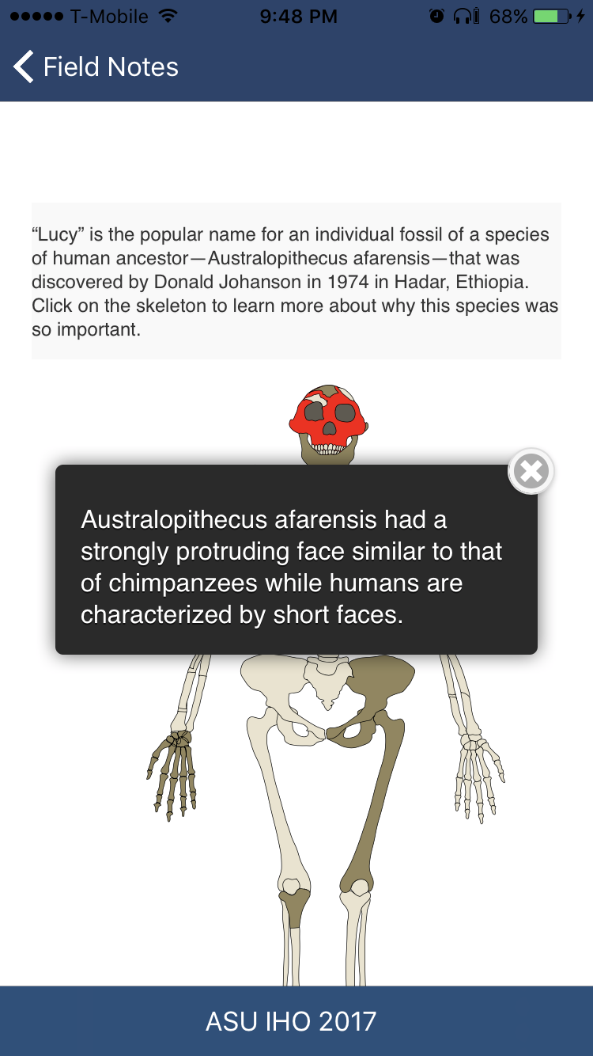

*Figure 17: Touch a part to see information about it.*

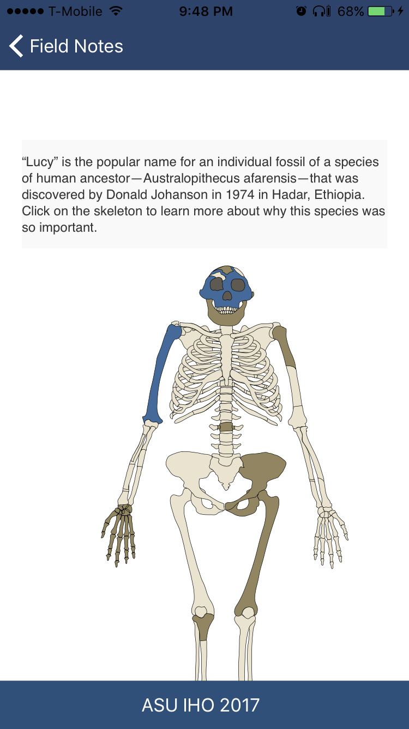

*Figure 18: After a part has been touched, the color changes to blue.*

**Update on Android app:** We have successfully resolved the database exception. We are able to connect to the server and show the latest list of news which was updated in the swing app.

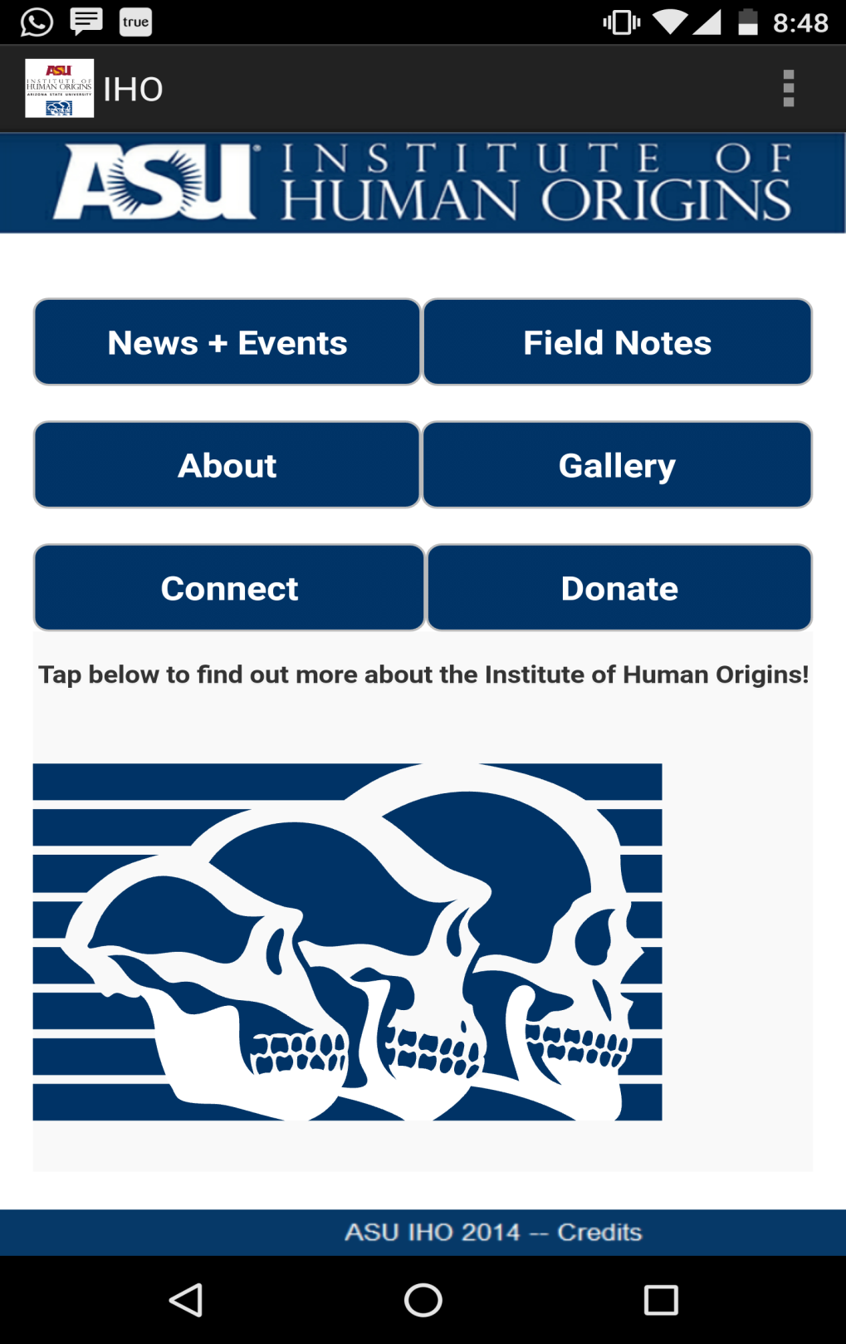

*Figure 14: This is application’s home page. The user can click any of the 6 buttons (New + Events, Field Notes, About, Gallery, Connect, Donate) to know corresponding information.*

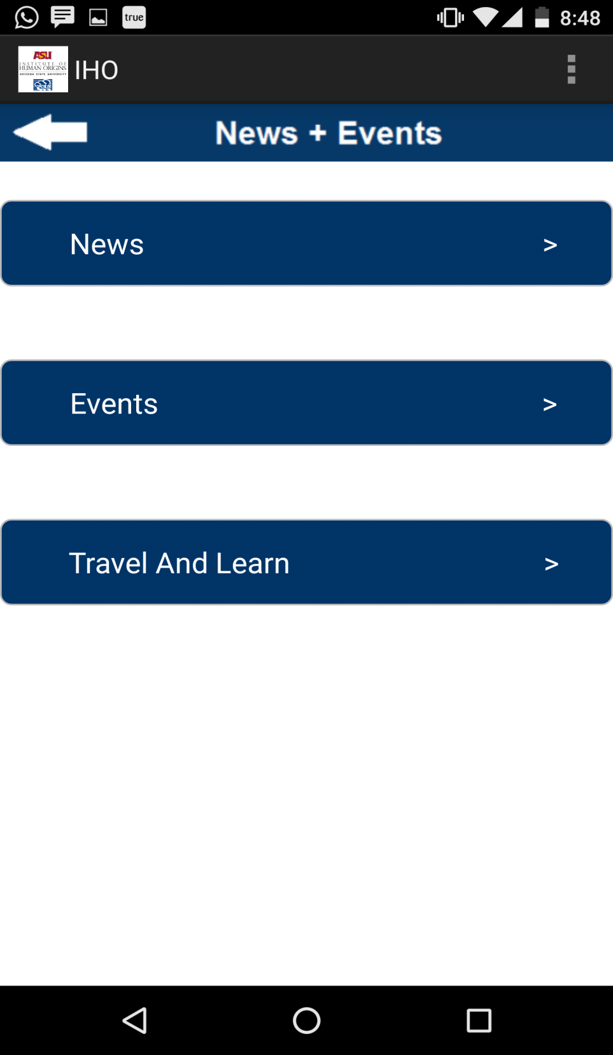

*Figure 15:The user is navigated to the above screen if he clicks on News + Events button from Home Page. Here, the user has options to view News, Events and Travel & Learn Information.*

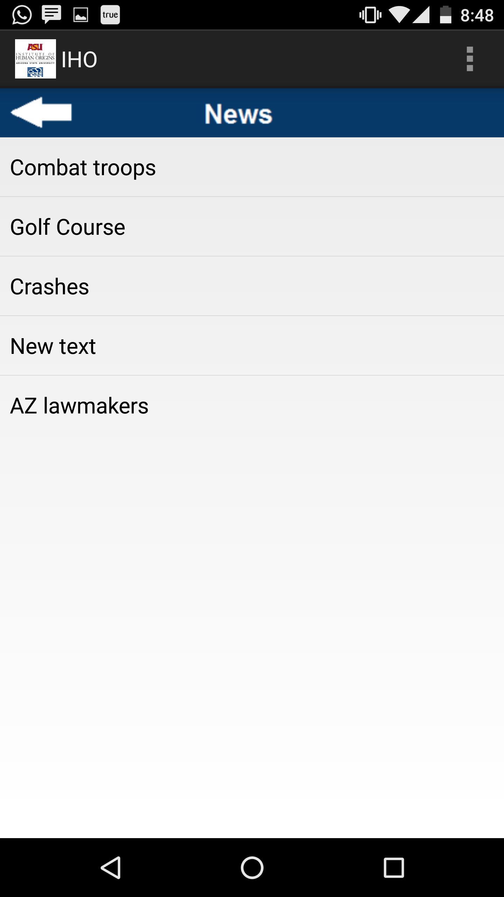

*Figure 16:On clicking “News” in the previous screen, fetches updated News List from the IHO Server, updates the local database and displays like above. User can now click on any of the “News” to know more about that. Prior to this project implementation, this section did not come up due to Database Exceptions and used to show static news from local database.*

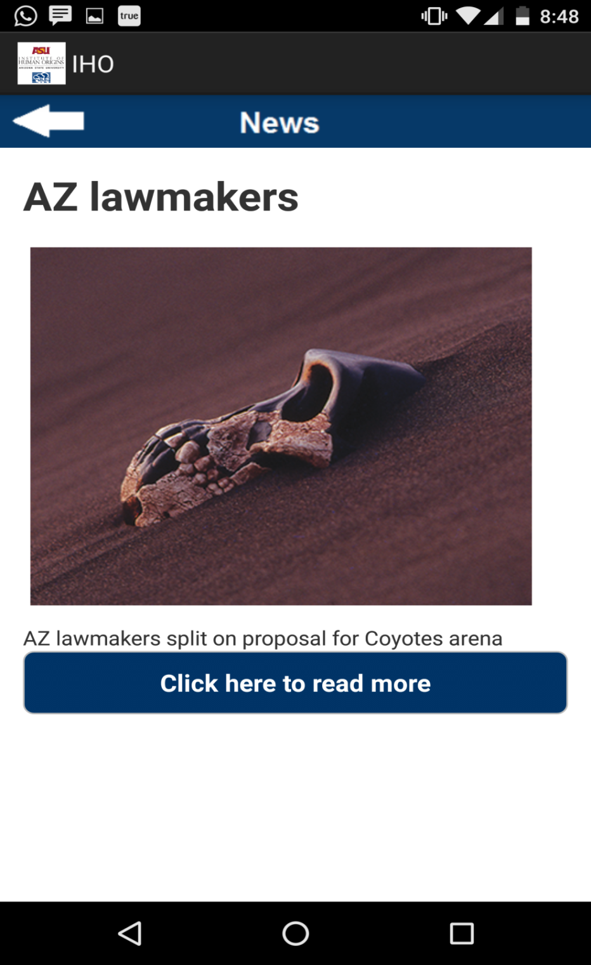

*Figure 17:On selecting particular News from the News List, opens up this screen to show detailed News Information. This screen show the updated information, fetched directly from the IHO Server.*

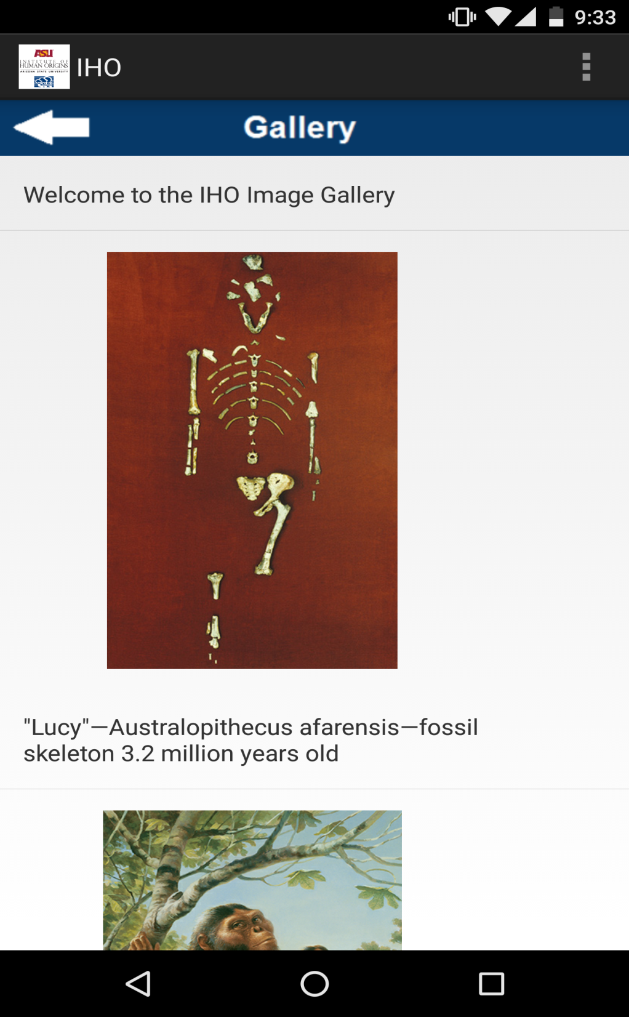

*Figure 18:This screen comes up when user clicks on “Gallery” button from Application’s home page. Earlier, clicking of gallery caused the application to shut down, because it was throwing Database Exceptions. Now, as database exceptions are removed and handled, this section now connects to the Gallery table in the database and to show pictures.*

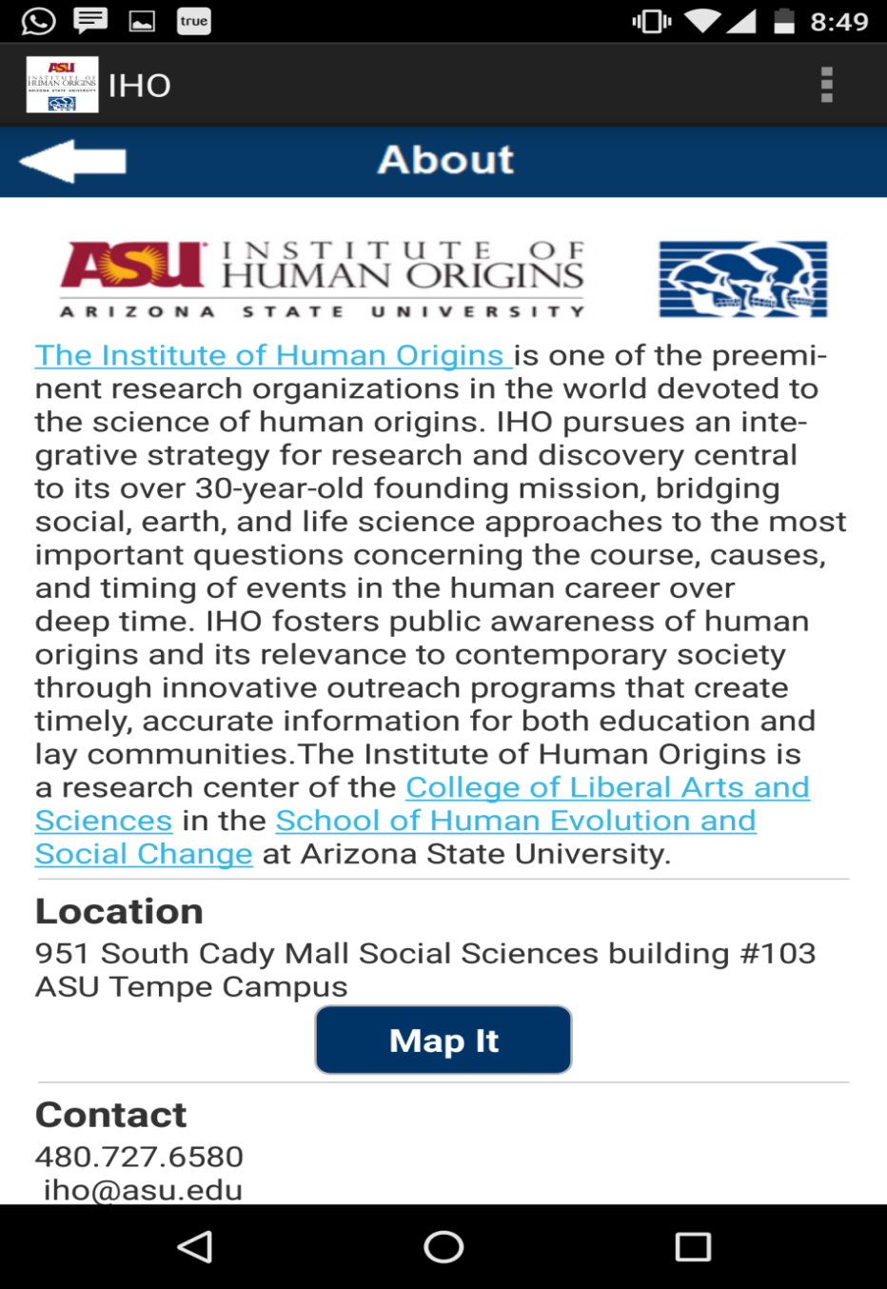

*Figure 19:This screen comes up when the user clicks on “About” button from the home page. It will display general information about ASU’s IHO Department, along with contact and location mapped on Google Maps.*